|  |
| --- |
| Predictive Health Notification  Alinity I Vacuum Pump |
| ALINITY ci Immunoassay Analyzer  Anthony Schuler  July 9, 2018 |

**PHN - Alinity i Vacuum Pump Spec Sheet for Apollo**

**References**

APLM ID

**Summary**

To implement a Predictive Health Notification (PHN) for Alinity-i Analyzers that will detect reduced vacuum pump performance caused by vacuum pump valve issues.

|  |  |
| --- | --- |
| PHN Descriptor | Alinity IA Vacuum Pump |
| PHN Experience Code / Name | CCE2 PHN_Alinity_IA; PHN_Vacuum_IA; Pump |
| PHN KM Article Number/ Name | K72294393 PHN Alinity IA: Vacuum Pump |
| Skill Level | 2- Advanced Service |
| Always On Package | Always On 01DP5- 01, 02, 03, 09, 70, 80, 83, 84, 89 |
| IDA Table | IDAQOWNER.ICQ_VACUUMPRESSUREDATA |
| IDA Table Fields | MODULESN,  VACUUMSTATENAME,  VERIFYVACUUMSUBSTATENAME, ADCVALUE,  LOGDATE_LOCAL |
| Analysis Frequency | Daily |
| Data Required | Previous 1 day |
| Data Aggregation | Minimum |
| Run Time Estimate | N/A |
| Flag Criteria | For each MODULESN:  If Min ADCValue per day>2160 then **Flag**,  else **No Flag**. |
| Probable Failure Modes | Broken or missing pump valves (flaps) on the pump heads. |
| Suppression Experience Codes | Z3OI |
| Applicable Work Done Codes (WDC) | CWC*: Fluid Movement: Vacuum failure: Other |

**Data Processing Steps**

|  |  |
| --- | --- |
| Data Processing Steps | |
| 1 | Query all data from the previous day for each instrument (IDA Table: IDAQOWNER.ICQ_VACUUMPRESSUREDATA). |
| 2 | Include data points where VACUUMSTATENAME = 'VerifyVacuum' AND VERIFYVACUUMSUBSTATENAME = 'DisableVacuum'. |
| 3 | Exclude instruments where the number of data points is < 30. |
| 4 | Summarize the data by calculating the minimum ADCVALUE by instrument. |
| 5 | Flag any instrument where the minimum ADCVALUE is > 2160. |

**APPENDIX 1:** CCE2 PHN_Alinity_IA; PHN_Vacuum_IA; Pump

**Algorithm Code**

SELECT

evals.MODULESN

FROM

(SELECT

I.MODULESN,

CASE WHEN I.VACUUMSTATENAME || I.VERIFYVACUUMSUBSTATENAME = 'VerifyVacuum'

THEN 'DisableVacuum'

END AS Vac_STATE,

MIN(I.ADCVALUE) AS MIN_ADCVALUE,

COUNT(I.ADCVALUE) AS NUM_EVALS

FROM

IDAQOWNER.ICQ_VACUUMPRESSUREDATA I

WHERE

I.LOGDATE_LOCAL >= TRUNC(SYSDATE) - 1

AND I.LOGDATE_LOCAL < TRUNC(SYSDATE)

AND I.VACUUMSTATENAME = 'VerifyVacuum'

AND I.VERIFYVACUUMSUBSTATENAME = 'DisableVacuum'

GROUP BY

I.MODULESN,

I.VACUUMSTATENAME,

I.VERIFYVACUUMSUBSTATENAME

ORDER BY

I.MODULESN,

I.VACUUMSTATENAME,

I.VERIFYVACUUMSUBSTATENAME

) evals

WHERE

evals.MIN_ADCVALUE > 2160

AND evals.NUM_EVALS >= 30

**Apollo Algorithm Details**

(* is Mandatory)

|  |  |
| --- | --- |
| **Apollo Details** |  |
| Algorithm ID * | Alinity IA Vacuum Pump |
| Algorithm Name * | Alinity IA Vacuum Pump |
| Algorithm Description * | To detect reduced vacuum pump performance caused by vacuum pump valve issues. |
| Product Family * | Alinity IA |
| Algorithm Group * | Alinity Waste |
| Functional Area | N/A |
| Algorithm Category 1 | N/A |
| Algorithm Category 2 | N/A |
| Algorithm Category 3 | N/A |
| Remaining Useful Life Value | 7 |
| Remaining Useful Life Unit | Day |
| Keep Results Num Days | 14 |
| **Routine Details** |  |
| Routine Source | Define New Routine |
| Routine Type | Oracle Procedure |
| Run Mode | Batch |
| Routine Invoke Command | PHM_ICQ_Vacuum_Pump_Proc |
| Status | Enable |
| **ODS Routine Details** |  |
| ODS Routine Name | PHM_ODS_ICQ_VACUUMPMDATA_PROC |
| **Predictive Health Notification Details** |  |
| PHN Code | PHN_Alinity IA_CCE2 |
| Issue Description (Use Algorithm Name) |  |
| Experience Code | CCE2 |
| **Knowledge Management DB Articles** |  |
| KM Article ID | K72294393 |
| KM Article | PHN Alinity IA: Vacuum Pump |
| **Parameters** |  |
| Parameter Group Name | ICQ_VACUUMPUMP |
| **Parameter Name** | **Parameter Values** |
| IHN_LEVEL3_DESC | AIinity IA Vacuum Pump |
| VACUUMPUMP_STATENAME | VerifyVacuum |
| VACUUMPUMP_MINADC | 2160 |
| VACUUMPUMP_NUMEVALS | 30 |
| THRESHOLDS_COUNT | 1 |
| THRESHOLD_DESCRIPTION | AIinity IA Vacuum Pump |
|  |  |
| **Chart Details** |  |
| Chart Title | Alinity IA Vacuum Pump |
| Chart Type | Line Chart |
| Chart Threshold Parameter | ICQ_VACUUMPUMP-THRESHOLDS_COUNT |
| Group ID | Group 7 |
| Chart X Axis Name | Date |
| Chart Y Axis Name | Threshold Count |

**APPENDIX 2:** Algorithm Understanding Check – Algorithm Developer to Predictive Health Monitoring (PHM) Specialist Transition

This step is not necessary. For this algorithm, the Algorithm Developer provided the necessary code to implement the algorithm. As such, there was no “hand-off” of the algorithm from Algorithm Developer to PHM Specialist, and no Understanding Check was necessary. Proper algorithm functionality was checked by the original developer of the algorithm.

**APPENDIX 3:** Algorithm Transition to Apollo – PHM Specialist to Apollo Developer

**Data Set Description**

The data set for this transition was retrieved from the IDAQOWNER.ICQ_VACUUMPRESSUREDATA table within the DABBTO database. Data was collected for all available instruments on June 23, 2018 and June 24, 2018.

**PHM Specialist Analysis Output**

The following 8 instrument-days (MODULESN-DAY) were identified as violating the algorithm by the PHM Specialist:

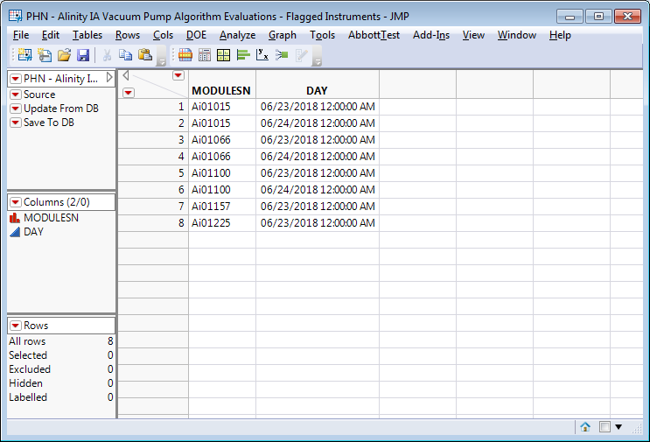

**Apollo Developer Analysis Output**

The following 8 instrument-days (SN-FLAG_DATE) were identified as violating the algorithm by the Apollo Developer:

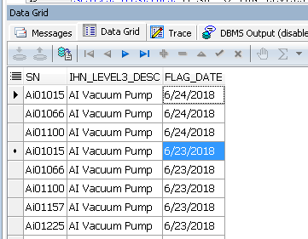

**Algorithm Transition Summary**

Based on the outputs from both the Apollo Developer and PHM Specialist, the Apollo Developer’s understanding of the delivered algorithm is confirmed. Both the Apollo Developer and PHM Specialist analyzed the same data set and got the same results. In particular, the MODULESN/SN and DAY/FLAG_DATE fields matched. This means that both the Apollo Developer and PHM Specialist flagged the same algorithm violations within the given data set.